**Juego Documentation**

This is the official documentation of the game Juego: A 3D Dungeon Crawler Puzzle Game.

Color Legend:

* Function
* Script
* GameObject
* Parameter

**Player-Object Interaction**

**PInteractionManage**r **Script**

**Parameters**

|  |  |
| --- | --- |
| playerManager | The PlayerManager component. |
| inputHandler | The InputHandler component. This component is essential for triggering the Interactable script. |
| interactableObject | The GameObject which the collider collided with. Should be null if there are no Interactable component from the collided object. |
| uiManager | The UIManager component from the PlayerUI. This component is essential for displaying the interactText from the interactableObject. |
| canInteract | Indicates if the player can interact with the object or not. This must always be public. |

**Description**

PInteractionManager handles the interaction with the player and the Interactable script.

When OnTriggerEnter() is called, this script gets the Interactable component from the object the collider collided.

The InteractWithObject() function calls the Interact() function from the Interactable script. Always call the Interact script when calling a script that has inherited the Interact script.

**Interactable Script**

**Parameters**

|  |  |
| --- | --- |
| radius | No idea. |
| interactableText | The text to be shown when the player can interact with the object. |

**Description**

This script handles the interaction with the PInteraction script and the Activatable script. Always inherit this script for activatable puzzle objects**.**

**How to inherit**

1. Create a script.
2. Add the namespace J.
3. Replace MonoBehaviour with Interactable

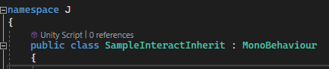

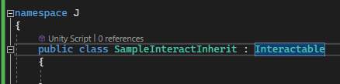

1. 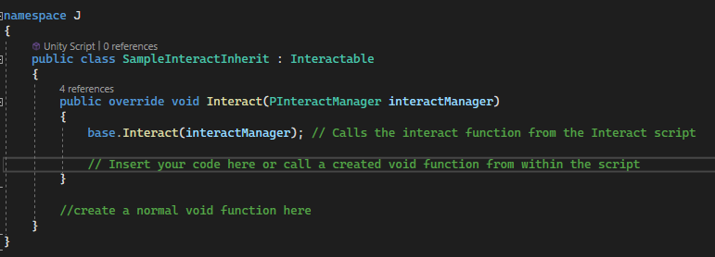Insert the Interact function as seen below. Do not forget the override before the void.

**ActivatePuzzlePiece Script**

Parameters

|  |  |
| --- | --- |
| objectToBeActivated | References the Activatable script from the target object of the Interactable script. |

**Description**

Inherits the interactable script.

This script can be used for simple interactable puzzle piece like a door switch for example.

**How to use:**

1. Attach this script to a game object.
2. Set the interactableText.
3. 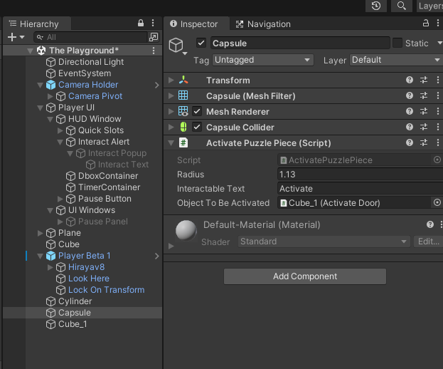Set the objectToBeActivated.

**Activatable Script**

Parameters

|  |  |
| --- | --- |
|  |  |

Description

This script must be inserted to an obstacle (door, bridge) that is must be activated by the player.

**ActivateDoor Script**

This script inherits the Activatable script. It overrides the DoSomething() function.

This script destroys the door. It is subject to change.